**CHARTER TOWNSHIP OF WILLIAMS  
PLANNING COMMISSION**

**NOTICE OF PUBLIC HEARING**

**Date: February 3, 2025**

**Time: 7:00pm**

**AT TOWNSHIP HALL**

**Address: 1080 W. Midland Rd, Auburn, MI 48611**

**TAKE NOTICE** that the Planning Commission for Williams Charter Township, Bay County, Michigan will hold a hearing on February 3, 2025, at 7:00pm at the Township Hall at 1080 W Midland Rd, Auburn, MI 48611. The purpose of the meeting and public hearing will be to consider amendments to the Township Zoning Ordinance regarding siting, and approval of (1) wind energy projects, (2) solar energy projects, and (3) battery energy storage projects within the Township including, but not limited to, setbacks, noise, decommissioning and other requirements and to consider any other Planning Commission business that may come before the Planning Commission. The wind, solar and battery energy ordinances also create an overlay district for alternative energy projects to consist of the following area:

The entirety of sections 06 and 07 within the Township, and the northern half of section 30 within the Township.

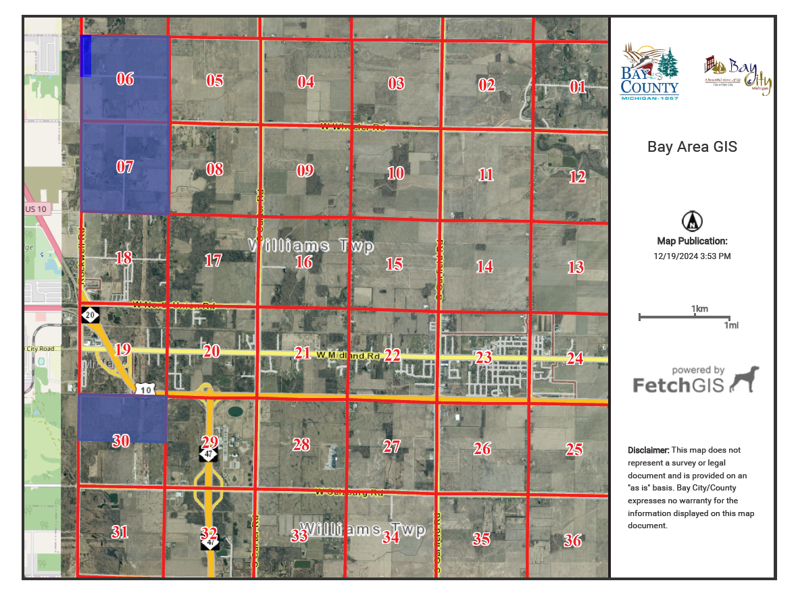

A copy of the proposed ordinances may be obtained at Township Hall during regular business hours, and the Township may charge a reasonable fee for copies. Monday through Thursday excluding holidays. You are welcome to attend, have others attend in your stead and represent you, or provide written feedback to the Planning Commission regarding this issue. You may inspect the proposed amendments at the office of the Township Clerk between the hours of 8:30 a.m and 4:00 p.m. Monday through Thursday, excluding holidays. The Township will receive written comments concerning the proposed amendments at the Township Hall, 1080 W Midland Rd, Auburn, MI 48611. Written comments must be received by the Township Offices prior to the day of the hearing on February 3, 2025, at 7:00pm.

This notice is posted in compliance with the Open Meetings Act and the Americans with Disabilities Act. Individuals with disabilities requiring auxiliary aids or services who are planning to attend the meeting should notify the Clerk, Kellie Andrus, [Clerk@williamstwp.com](mailto:Clerk@williamstwp.com) within a reasonable time in advance of the meeting.

89555:00001:201115653-1